Ideation Phase
Brainstorm & Idea Prioritization Template
Date
Team ID
Project Name | Automated Network Request Management in ServiceNow
Maximum Marks | 4 Marks
Brainstorm & Idea Prioritization Template:
Brainstorming provides a free and open environment that encourages everyone within a team to participate in the creative thinking process that leads to problem solving. Prioritising volume over value, out-of-the-box ideas are welcomed and built upon, and all participants collaborate to develop a rich set of creative solutions.
For the Automated Network Request Management in ServiceNow project, the team used this exercise to move from the problem statements to a concrete, prioritised set of automation ideas for the ServiceNow implementation.
Step 1: Team Gathering, Collaboration and Idea Generation
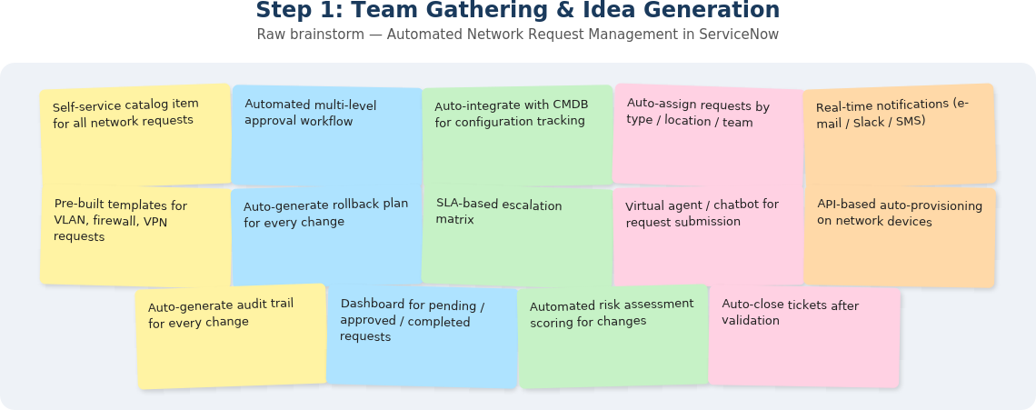
Figure 1: Raw brainstorm — Automated Network Request Management in ServiceNow
Step 2: Brainstorm, Idea Listing and Grouping
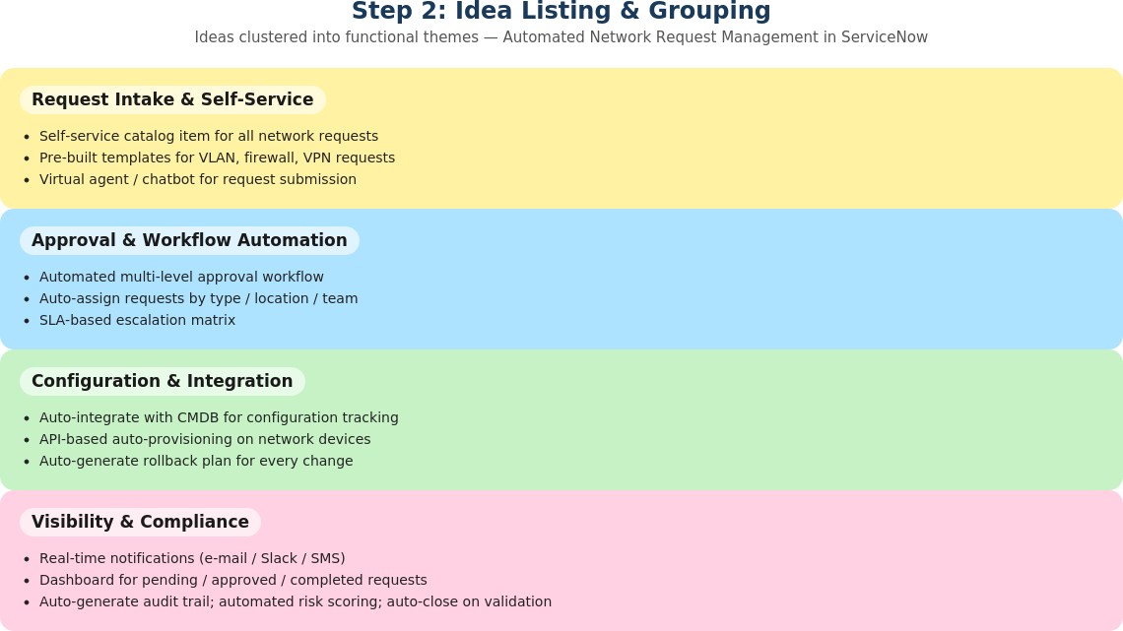
Figure 2: Ideas grouped into functional themes
Step 3: Idea Prioritization
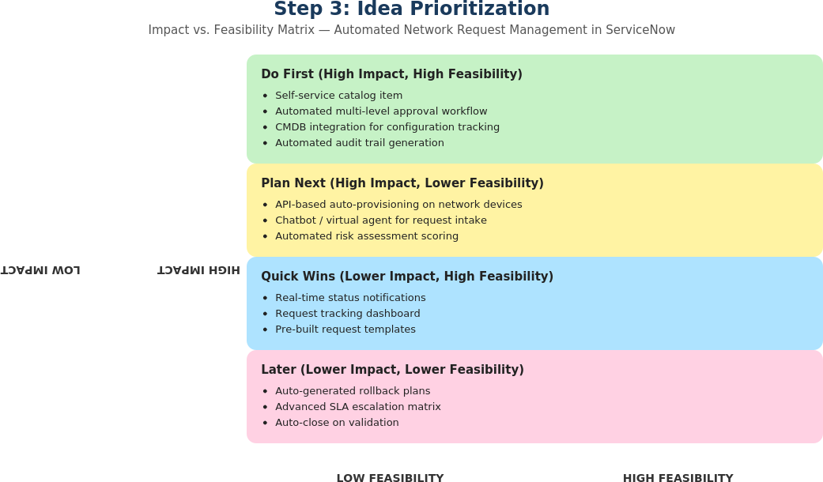
Figure 3: Impact vs. Feasibility prioritization matrix

